Daniel Elias Becerra A01208905

Hugo David Franco Ávila A01654856

Roberto Núñez Alanís A01205559

***Group Project proposal***

***Purpose***

The purpose of this group project is to analyze, design, program and simulate two vending machine that have an interaction with an user. The information the vending machines have will be stored in files that can be edited by the user; thus, the user can reload the machines, retrieve or add money to it.

*Ideas for vending machines:*

* A vending machine that sells technologic gadgets (phones, USB’s, headphones, etc…).
* A vending machine that Sells food (soda, chocolates, candy, etc.)

***Characteristics:***

* It will have a graphical user interface that simulates two vending machines.
* The user can select which vending machine to use.
* The user can only use one vending machine at a time.
* Products’ information and available money will be stored in files.
* The machine can be loaded with more product and more money.
* It will have at least two packages (one for the graphical user interface, one for the logic/structure of the vending machine behaviour).

1. Main menu to select which vending machine to use
2. User selects a vending machine like a button with a click using the mouse/trackpad.
3. Show a menu of available products and their costs, a number associated with it.
4. User can select a product introducing the number of the product.
5. Vending machine displays characteristics of the product selected
6. Vending machine displays costs.
   1. If the user introduced a wrong number, the vending machine tells him to make another selection.
7. Vending machine checks in the file if the product is still available
   1. If the product selected is no longer available, the vending machine tells the user to make another selection
8. User can select ok or cancel or select another product.
9. Machine displays a message telling the user to introduce the money to pay for the product.
10. User introduces money. The user starts with a certain amount of money, the user can have a method called work() to obtain money in case they don’t have any money.
11. Vending machine saves in a file the number of products remaining
12. Vending machine saves in a file the products that have been sold.
13. Vending machine saves in a file the money that it has obtained
14. The machine tells the user how much money he or she still needs to introduce after the user introduced a certain amount of money.
15. If the user introduced an exact amount of money:
    1. Vending machine sells the product
    2. Vending machine displays message: “”product” sold
    3. The vending machine displays the Confirmation message
16. If the user introduced more money:
    1. The vending machine tells the user his change
    2. The vending machine gives the user his change (the program has to let the machine calculate the change and select how many coins or dollars of each type the vending machine has to return to the user)
    3. After giving the user his or her change, the vending machine displays the confirmation message
    4. If the user has not enough money, the machine tells him or her he needs more money to pay.
17. The screen returns to the main menu
18. User can select “exit the program” in the main menu
19. The user can also log in as an administrator.
20. The administrator can include more products in the file that stores the products available.
21. The administrator can also retrieve or load money into the machine
22. Each vending machine will have 9 objects or products.

Controls

* The mechanical attributes of the machine will be controlled with the mouse.
* The information about the vending machine and the user will be edited with the keyboard.

***How will it look:***

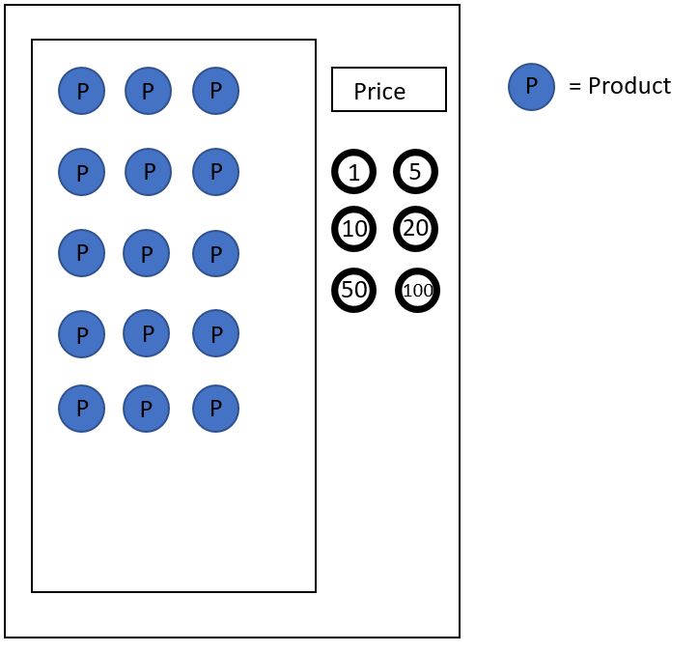

Buttons with numbers = amount of money the user is introducing

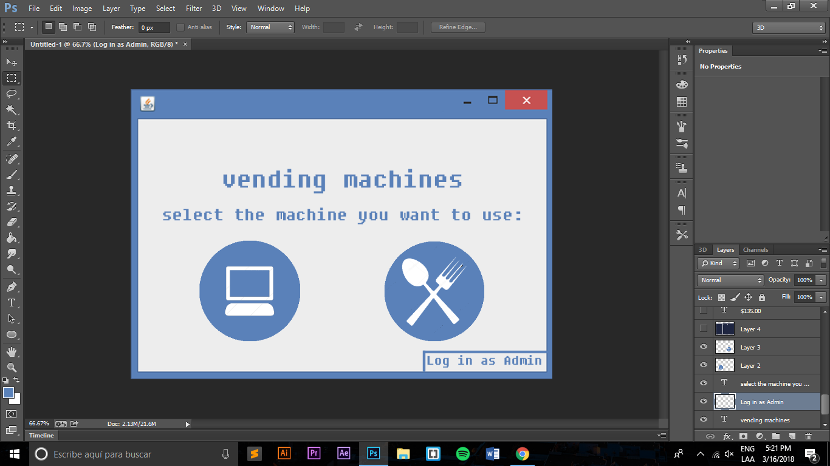

Possible example:

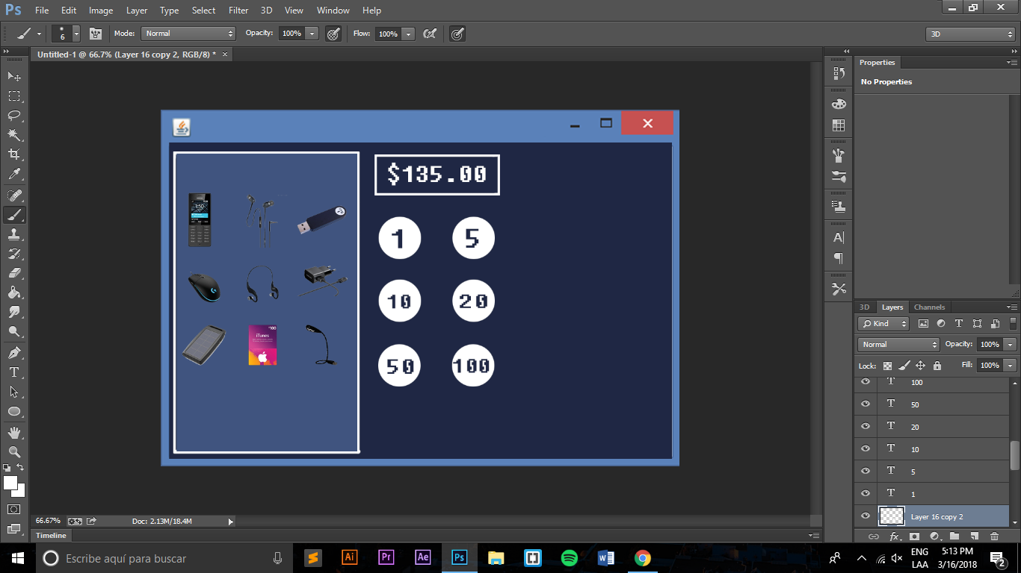

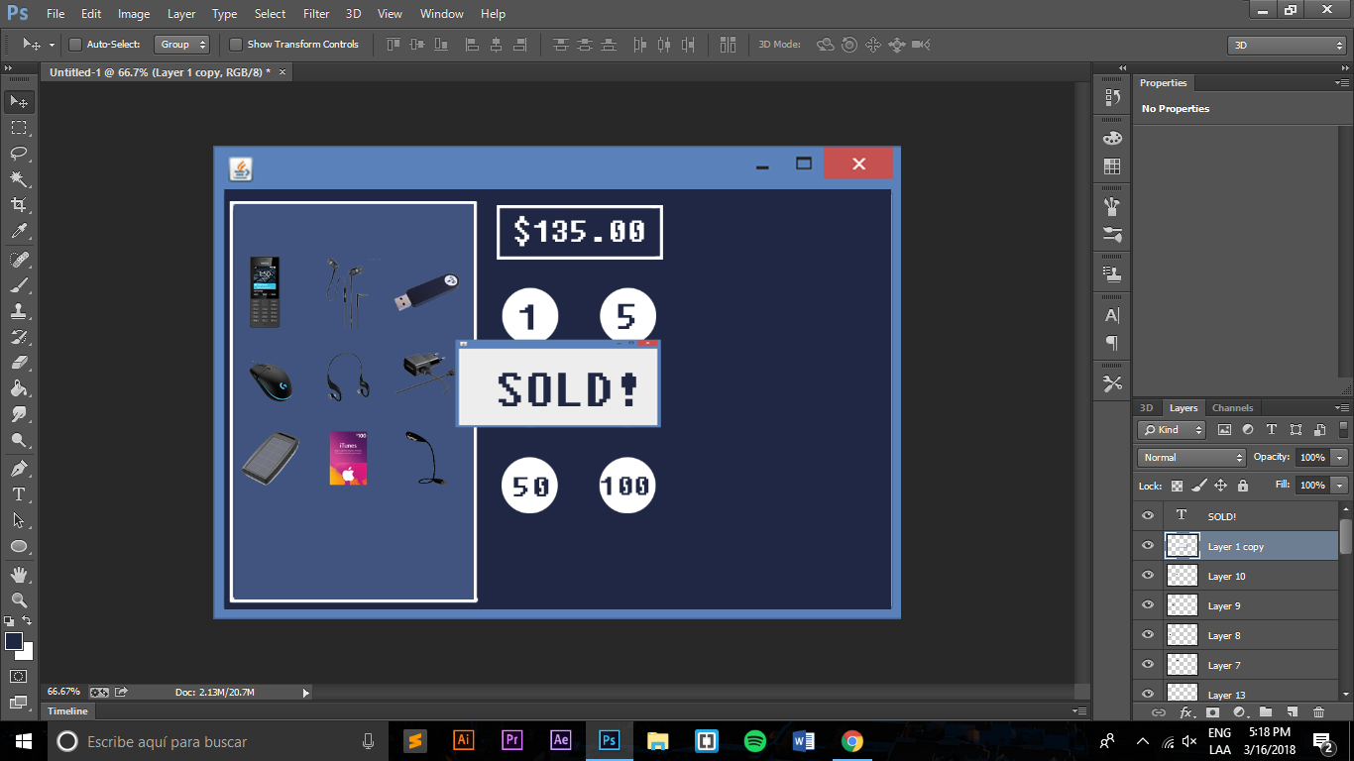

If the user selects login as admin

